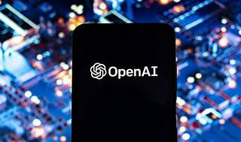

Explore

[The **OpenAI framework** is a comprehensive developer platform that provides tools, tutorials, and APIs for building and exploring natural language processing (NLP) models, including chat completions, text generation, and more1](https://platform.openai.com/overview). Here are five free resources to enhance your understanding:

1. **Quickstart Tutorial**: Dive into the basics and learn how to make your first Chat Completions API request. [Explore here](https://platform.openai.com/overview).
2. **Assistants Deep Dive (Beta)**: Understand the intricacies of building an assistant using OpenAI models. [Learn more](https://platform.openai.com/overview).
3. **Text Generation**: Discover techniques for generating text with OpenAI models. [Explore text generation](https://platform.openai.com/overview).
4. **Prompt Engineering Best Practices**: Learn how to create effective prompts for better model responses. [Check out prompt engineering](https://platform.openai.com/overview).
5. [**OpenAI Preparedness Framework (Beta)**: Explore OpenAI’s safety processes for handling powerful models and mitigating risks](https://platform.openai.com/overview)[2](https://openai.com/safety/preparedness).

Happy learning! 🚀